Monitoring and managing soil structure
Good soil structure is vital for optimising water and nutrient use efficiency; and for sustaining profitable cropping systems. Poor soil structure and compaction can reduce yields, restrict access for field operations, increase fuel use and, for high value root and vegetable crops, increase reliance on irrigation. Where there are clear signs of soil compaction, cultivations to remove the compaction may result in a yield benefit. Visual soil assessment is important to assess the extent and depth of compaction and to inform decisions on the most appropriate course of action.
- Assessing soil structure
Ideally, soils should be assessed when they are ‘moist’ and soil aggregates are easy to break up by hand. If the soil is too ‘wet’ soil units may stick together, and the spade or fork can smear the soil. Late autumn (when drains are running on heavier land) to early spring (on a ‘drying front’) is usually better than in mid-summer, when soils are often too ‘dry’. Avoid assessing soils during prolonged spells of wet or dry weather. The two key questions you need to answer when assessing your soils are:
- Is the topsoil well structured, i.e. can roots explore the entire topsoil volume for nutrients?
- Are there signs of a cultivation pan that is restricting root development or drainage?
Use roots and soil drainage as indicators of good/poor structure. Roots are often the best indicators of soil compaction. Finer roots will run horizontally across the surface of a compacted layer and tap roots similarly become pronged and run laterally if they cannot push through the soil. Drainage in winter is another good indicator. Soils will often ‘sit wet’ above a compacted layer making the saturated layer susceptible to further compaction.
- Well targeted cultivations
If you have identified a compacted layer, you should consider cultivation to remove this compaction.
- Do not subsoil unless you have identified clear signs of compaction
- Subsoiling soils that are in good condition is likely to do more harm than good!
Suitable conditions - Subsoiling should only be carried out when the soil at working depth is in a 'dry' and friable condition, so that it will shatter rather than smear. Examine soils early in the operation to ensure effective shattering is occurring.
Both the soil surface and the compacted layer should be 'dry' to avoid soil structural damage.
Choice of equipment - Winged subsoilers shatter the soil much more effectively than conventional subsoilers. They require higher draught force but can disturb a volume of soil two to three times greater than a conventional subsoiler, resulting in more effective disturbance.
The use of leading tines can result in an increased volume of soil disturbed without increasing draught.

Depth - It is best practice to use a depth wheel or rear packer roller to maintain a constant tine depth (Figure 1). Aim for tines to be about 25–50 mm below the base of the compacted layer, up to a maximum depth of approximately 450 mm below ground level.

Maximum depth may be limited by shallow field drains, rock or the critical depth of the tine (related to tine width and soil conditions). Normal drain depth is around 70 to 90 cm below the soil surface.
Do not cultivate any deeper than you have to:
- Doubling the tine working depth can quadruple the draught force requirement
- Increasing the working depth by 5 cm (two inches) can easily double the fuel requirement
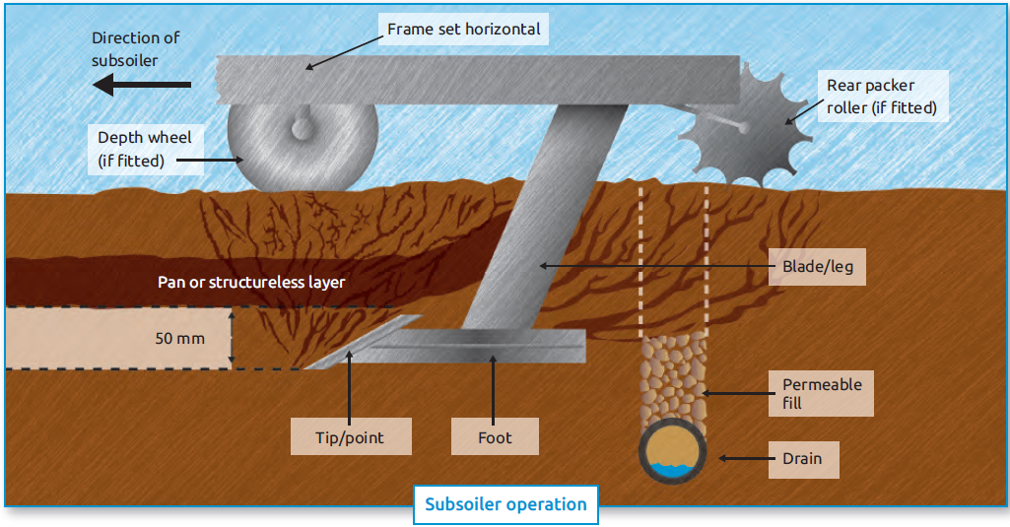
Figure 1. How a subsoiler works (from AHDB Field Drainage Guide)
Working deeper than you need to not only produces undesired soil disturbance, but also causes an unnecessarily large increase in the draught requirement, which increases fuel consumption, wear and tear, and wheel slip, which will cause smearing and further soil structural damage.
Spacing between tines – many subsoiler manufacturers now have fixed tine spacings on their subsoilers. However, it is important to use the following tine spacing where possible.
  - Conventional subsoiler: up to 1.5 times the tine depth
  - Winged subsoiler: up to 2 times the tine depth
  - With leading shallow tines: up to 2.5 times the tine depth

After a trial run, dig down and examine the result. Adjust spacings, where possible, to achieve the desired degree of soil disturbance.
Avoiding re-compaction - Recently loosened soils are very sensitive to re-compaction. Avoid running over land that has already been subsoiled.
There are a number of methods and guides which provide more detailed guidance on how to assess soil structure and manage soil cultivations:
- The Think Soils guide uses terms and descriptions and photos to help growers assess their soil structure, and provides management advice for different soil types.
- The “Visual Soil Assessment” (VSA) method from Landcare Research in New Zealand has been adapted by Linking Environment and Farming (LEAF) in the UK to produce the ‘Simply Sustainable Soil’ guide.
- The Visual Evaluation of Soil Structure (VESS) focuses on assessing soil structure and porosity and the degree of layering in soils. This method involves the extraction of a soil block about the width and depth of a spade or fork and the pulling apart of the block by hand to assess ease of break up, visual appearance (size, shape and arrangement of soil structures, pores and roots), colour and smell.
- The AHDB Arable Soil Management: Cultivation and crop establishment guide provides information on arable cultivation and establishment systems.

Paul Newell Price and Lizzie Sagoo

